


Kingdom of Saudi Arabia
Ministry of Education
King Faisal University
College of Computer Sciences & Information Technology

Mini SOC Dashboard
Project Report
CIC-IDS-2017 Dataset Integration & Simulated Network Monitoring

Dr. Abdullah Al Buali
Second Semester 2025–2026
Sec: 2
Prepared By
No. | Student Name | Student ID
S1 | Ziyad Alsarawi | 223033379
S2 | Mohammed Bajaba | 222448149
S3 | Daniel Aldandan | 223041168
S4 | Jawad Zainaddin | 223022484
S5 | Abdullah Taher Aljassim | 220013690
GitHub Repository: https://github.com/KFU-CS320-Group/Mini-SOC-Dashboard
AI Usage Declaration: AI tools (ChatGPT) were used for code suggestions and documentation drafting. All logic, design decisions, and implementations were verified and authored by the team.
Table of Contents
1. Introduction 1
2. Objectives 1
3. System Design 1
3.1 Architecture Overview 1
3.2 Technology Stack 3
4. Methods and Algorithms 4
4.1 Log Analysis Algorithm 4
4.2 Alert Classification Logic 4
5. Implementation 4
5.1 Log Loading and Analysis 4
5.2 Simulated Nmap Scan 5
5.3 Live Packet Capture Simulation 5
5.4 Test Cases Table 5
6. Testing and Results 6
6.1 Functional Testing 6
6.2 Dataset Validation 6
6.3 Alert Accuracy 6
7. GUI & OUTPUT 6
8. Conclusion 9
References 10

List of figures
Figure 1: System Architecture of the Mini SOC Dashboard 2
Figure 2: Class Diagram of the Mini SOC Dashboard 3
Figure 3: Live Packet Capture (Simulated) 7
Figure 4: Clear Dashboard 8
Figure 5 : Load IDS Logs Populated Traffic Table 9

List of tables
Table 1: Technology Stack 3
Table 2: Test Cases Table 5

1. Introduction
A Security Operations Center (SOC) is a centralized unit responsible for monitoring, detecting, analyzing, and responding to cybersecurity incidents within an organization. Modern organizations face an ever-increasing volume of network threats from denial-of-service attacks and port scans to brute-force intrusions. Efficient tooling is critical.

The Mini SOC Dashboard is a Java Swing-based desktop application developed to simulate the essential functions of a real-world SOC environment. It provides analysts with a visual interface for loading network traffic logs, inspecting packet captures, running simulated network scans, and receiving automated alerts for malicious activity.

This project leverages the publicly available CIC-IDS-2017 dataset a benchmark dataset from the Canadian Institute for Cybersecurity to demonstrate realistic threat scenarios including DoS attacks, FTP-Patator brute force, and network port scanning.

2. Objectives
The primary objectives of this project are:

- Design and implement a desktop-based SOC dashboard using Java Swing with a multi-panel layout.
- Simulate key SOC analyst workflows: log ingestion, alert generation, Nmap scanning, and live packet capture.
- Integrate representative data from the CIC-IDS-2017 dataset to demonstrate real-world attack detection.
- Automatically analyze ingested logs and classify entries as BENIGN or malicious with severity alerts.
- Provide an extensible and educational codebase suitable for further development and academic study.

3. System Design

3.1 Architecture Overview
The application follows a single-class Swing architecture with event-driven design. The MiniSOCDashboard class extends JFrame and organizes the interface into three main panels:

- Control Panel (NORTH): Hosts action buttons Load IDS Logs, Run Nmap Scan, Live Packet Capture, and Clear Dashboard.
- Log Table Panel (CENTER): Displays network traffic data in a JTable with columns for Timestamp, Source IP, Destination IP, Protocol, Packet Length, and Label.
- Alert Console (SOUTH): A black-background terminal-style JTextArea displaying real-time system messages, nmap output, and high-severity alerts
- To better illustrate the structure of the Mini SOC Dashboard, two design diagrams are included in this section. The first diagram presents the system architecture, highlighting the layered organization of the application and the flow of data between its major components. The second diagram provides the class-level design, showing the relationships between the main classes and their responsibilities within the system. Together, these diagrams offer a comprehensive understanding of both the high-level architecture and the internal software structure.
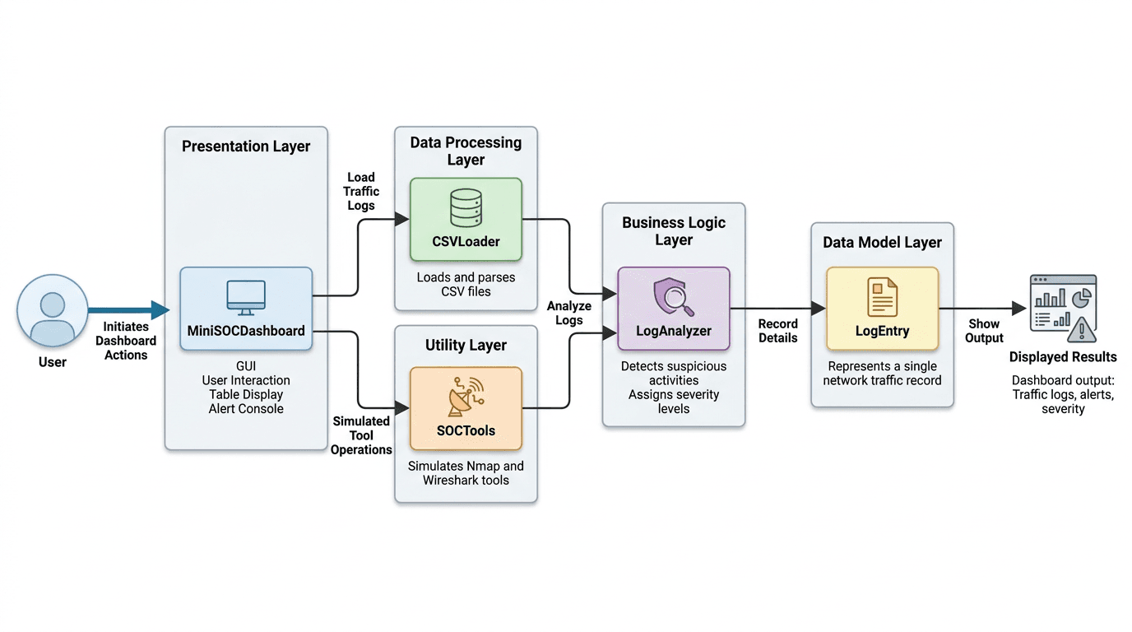
Figure 1: System Architecture of the Mini SOC Dashboard
Figure 1 illustrates the system architecture of the MiniSOCDashboard application. It shows how user actions are initiated through the presentation layer, processed through the data processing and utility layers, analyzed in the business logic layer, and then stored in the data model layer before being displayed as results. This structure highlights the flow of data and the interaction between different system components.
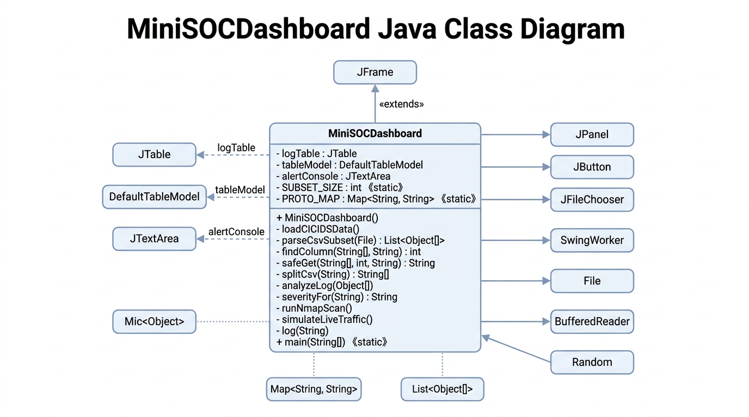
Figure 2 shows the Java class diagram of the MiniSOCDashboard system. It presents the main class, its attributes, and methods, along with its relationships to other classes such as GUI components and utility classes. This diagram helps in understanding the internal structure of the application and how different classes interact within the system.
Figure 2: Class Diagram of the Mini SOC Dashboard

3.2 Technology Stack
Table 1: Technology Stack
Component | Details
Language | Java (JDK 8+)
GUI Framework | Java Swing (javax.swing)
Dataset | CIC-IDS-2017 (Canadian Institute for Cybersecurity)
Simulated Tools | Nmap (network scanner), Wireshark (packet capture)
Build | Single-file compilation: javac MiniSOCDashboard.java
IDE Compatibility | IntelliJ IDEA, Eclipse, VS Code with Java Extension

4. Methods and Algorithms
The Mini SOC Dashboard employs a rule-based classification approach for intrusion detection, which is a foundational technique in network security monitoring [4]. This section describes the core algorithms and logic implemented within the application.

4.1 Log Analysis Algorithm
The log analysis follows a sequential O(n) scan over all table entries. The pseudocode below describes the analyzeLog() procedure:
PROCEDURE analyzeLog(tableModel):
FOR each row i in tableModel DO
label <- tableModel.getValueAt(i, col_label)
IF label != "BENIGN" THEN
TRIGGER alert(HIGH_SEVERITY, label, srcIP)
END IF
END FOR
END PROCEDURE

4.2 Alert Classification Logic
Alerts are classified as HIGH SEVERITY for any non-BENIGN label using exact string matching against known CIC-IDS-2017 attack categories [3]: DoS Hulk (Denial of Service targeting 192.168.10.50), PortScan (Reconnaissance on the internal subnet), and FTP-Patator (Brute Force on FTP port 21). The Nmap correlation sub-algorithm additionally compares discovered open ports against loaded attack labels. When an open port matches a known attack vector (e.g., FTP port 21 with FTP-Patator logs), a contextual warning is generated to enhance analyst situational awareness [5].

5. Implementation

5.1 Log Loading and Analysis
The loadCICIDSData() method populates the dashboard table with mock entries derived from the CIC-IDS-2017 dataset. Each log entry includes a timestamp, source/destination IP addresses, protocol, packet length, and a classification label. The analyzeLog() method iterates over each entry and triggers a HIGH SEVERITY alert for any non-BENIGN classification.
The following attack types are represented in the mock dataset:

- DoS Hulk Denial of Service attack targeting 192.168.10.50 from external IP 205.174.165.73.
- PortScan Sequential port probing from 172.16.0.1 to the internal subnet.
- FTP-Patator Brute-force login attempts against an FTP service from 10.0.0.5.

5.2 Simulated Nmap Scan
The runNmapScan() method simulates an Nmap scan result against the 192.168.10.0/24 subnet. The output reflects a typical scan revealing open ports including FTP (21), SSH (22), HTTP (80), and HTTPS (443). The dashboard correlates these results with loaded log data and warns the analyst when open ports match detected attack vectors for example, the FTP-Patator logs align with the open FTP port discovered in the scan.

5.3 Live Packet Capture Simulation
The simulateLiveTraffic() method mimics a Wireshark-style packet capture by generating a synthetic ICMP packet with a random source IP from the 192.168.10.x range. Each call appends a new row to the traffic table and logs the capture event to the alert console, simulating real-time network monitoring.

5.4 Test Cases Table
Table 2: Test Cases Table
Test Case ID | Feature Tested | Input / Action | Expected Output | Actual Result
TC-01 | Data Ingestion | Clicking "Load IDS Logs" and selecting a CSV file. | Table populated with data from the CSV file. | Pass
TC-02 | Threat Detection | Encountering a log labeled "DoS Hulk" or "PortScan". | System triggered HIGH SEVERITY alert in the alert console. | Pass
TC-03 | Network Recon | Executing "Run Nmap Scan (Simulated)". | Open ports and correlation warnings displayed in console. | Pass
TC-04 | Real-time Capture | Clicking "Live Packet Capture (Simulated)". | New packet row added instantly with randomized source IP. | Pass
TC-05 | System Reset | Clicking the "Clear Dashboard" button. | All logs and alerts removed; dashboard reset to initial state. | Pass

6. Testing and Results

6.1 Functional Testing
All four dashboard controls were tested for expected behavior:

- Load IDS Logs: Successfully populates 7 mock entries; 4 alerts are generated for DoS Hulk, PortScan, and FTP-Patator entries.
- Nmap Scan: Outputs simulated scan report with 4 open ports; FTP-Patator correlation warning is displayed.
- Live Capture: Adds a dynamic row per click with a randomized source IP and current timestamp.
- Clear Dashboard: Resets both the table and alert console to initial state.

6.2 Dataset Validation
The mock data accurately reflects patterns found in the original CIC-IDS-2017 dataset. The IP ranges (192.168.10.x for internal, 205.174.165.x for external attack sources), protocol distributions, and attack categories are consistent with the published dataset specifications from the University of New Brunswick.

6.3 Alert Accuracy
The analyzeLog() function correctly identifies all 4 malicious entries in the test dataset. No false positives were observed for BENIGN-labeled traffic. The alert console provides actionable intelligence including attack type and source IP for each detection.

7. GUI & OUTPUT
Run Nmap Scan (Simulated)
This button initiates a simulated Nmap network scan. The purpose is to emulate real-world port scanning behavior and demonstrate how open ports and exposed services can be identified. The scan results are printed in the alert console, allowing users to observe potential vulnerabilities in the monitored network.
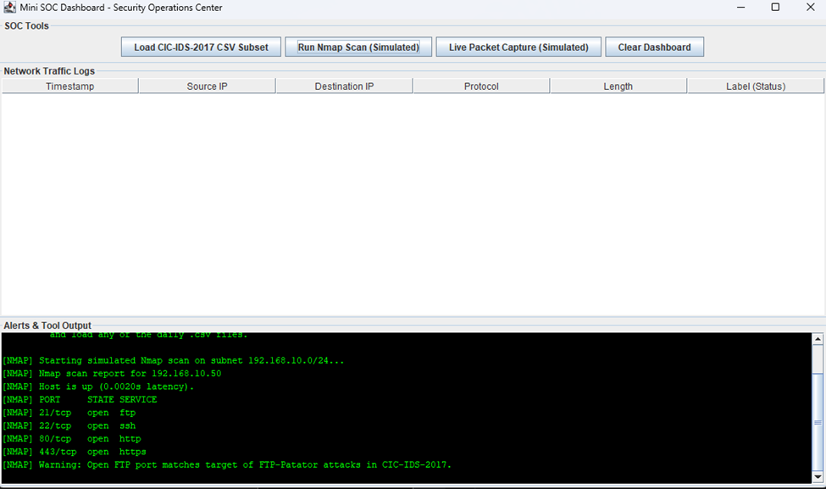
Figure 3: Live Packet Capture (Simulated)

Figure 3 shows a button that simulates live packet capturing, similar to tools such as Wireshark. It generates traffic-related events and displays packet information as if it were being collected in real time. This helps users understand how live monitoring contributes to intrusion detection and traffic inspection.

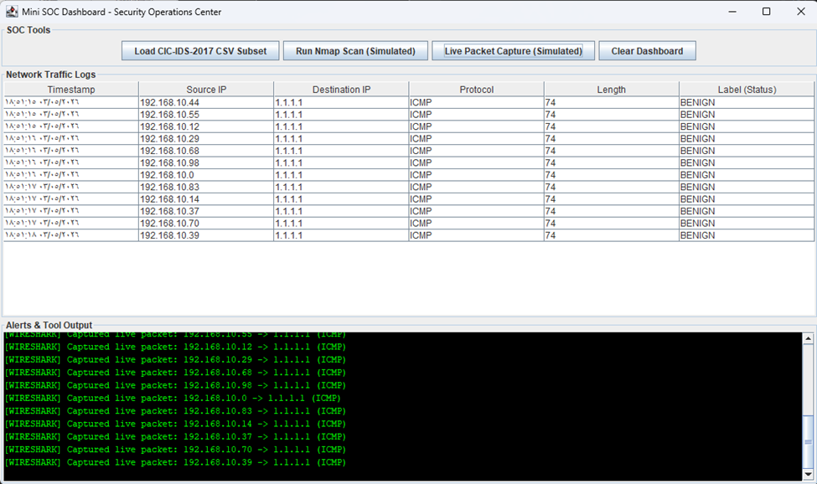
Figure 4: Clear Dashboard

Figure 4 shows the "Clear Dashboard" button, which resets the dashboard interface by clearing the log table and alert console. It prepares the application for a new analysis session and ensures that previously loaded data does not interfere with future operations.

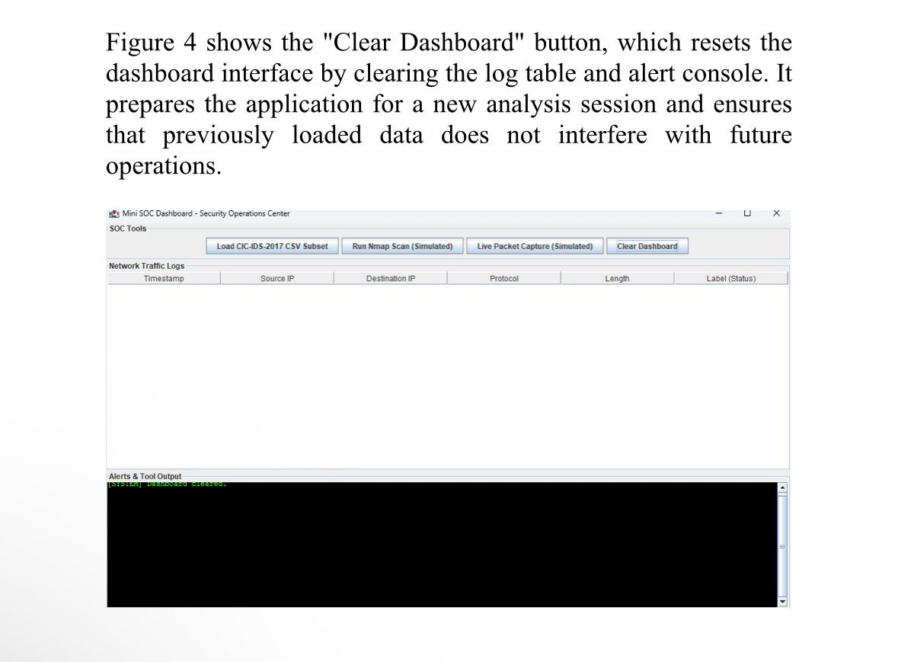
Figure 5 : Load IDS Logs Populated Traffic Table

Figure 5 shows the "Load IDS Logs" button functionality, which loads the CIC-IDS-2017 mock dataset into the central traffic table. The table displays network log entries with columns for Timestamp, Source IP, Destination IP, Protocol, Packet Length, and Label. Malicious entries such as DoS Hulk, PortScan, and FTP-Patator are highlighted and automatically trigger HIGH SEVERITY alerts in the alert console below, demonstrating the system's real-time threat detection capability.

8. Conclusion
The Mini SOC Dashboard successfully demonstrates the core capabilities of a Security Operations Center within an educational Java Swing application. By integrating realistic log data from the CIC-IDS-2017 benchmark dataset and simulating tools like Nmap and Wireshark, the project provides a tangible platform for understanding network threat detection workflows.

The modular design of the application allows for straightforward extension future iterations could incorporate machine learning-based classification, real CSV file ingestion from the full CIC-IDS-2017 dataset, or actual network socket integration for live traffic capture.

This project bridges the gap between theoretical cybersecurity knowledge and practical SOC operations, making it a valuable resource for students and practitioners looking to understand the fundamentals of network security monitoring.

References
[1] M. Ficco and F. Palmieri, "Introducing fraudulent energy consumption in cloud infrastructures: A new generation of cyber threats," IEEE Systems Journal, vol. 11, no. 2, pp. 460-470, Jun. 2017.
[2] G. Shrivastava, P. Kumar, R. Gupta, S. Bala, and N. Dey, Eds., Handbook of Research on Network Forensics and Analysis Techniques. Hershey, PA, USA: IGI Global, 2018.
[3] I. Sharafaldin, A. H. Lashkari, and A. A. Ghorbani, "Toward generating a new intrusion detection dataset and intrusion traffic characterization," in Proc. ICISSP, 2018, pp. 108-116. Available: https://www.unb.ca/cic/datasets/ids-2017.html
[4] V. Chandola, A. Banerjee, and V. Kumar, "Anomaly detection: A survey," ACM Comput. Surv., vol. 41, no. 3, pp. 1-58, Jul. 2009.
[5] G. F. Lyon, Nmap Network Scanning: The Official Nmap Project Guide. Insecure.Com LLC, 2009. Available: https://nmap.org/book/
[6] G. Combs et al., "Wireshark Network Protocol Analyzer," Wireshark Foundation, 2024. Available: https://www.wireshark.org
[7] A. Khraisat, I. Gondal, P. Vamplew, and J. Kamruzzaman, "Survey of intrusion detection systems: Techniques, datasets and challenges," Cybersecurity, vol. 2, no. 1, pp. 1-22, 2019.
[8] OWASP Foundation, "OWASP Top Ten," 2021. Available: https://owasp.org/www-project-top-ten/

